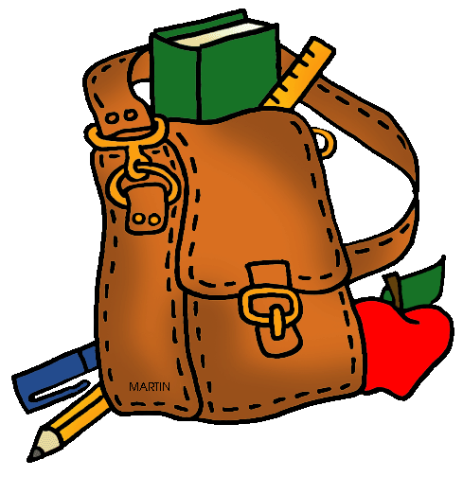
The Day at a Glance

8:00 Come into class, wash hands, move attendance clip and begin morning work.
8:30 Morning stretch and run
8:45 Language Arts (Whole group instruction, Language Arts Centers - includes support activity, following direction activity, penmanship, small group instruction.
9:45 Reading (includes independently, partner and group lead)
10:00 Restroom Break and Snack
10:15 Recess
10:30 Math (Whole group Instruction w/ white boards, Partner Work, Independent work, technology support)
11:30 Clean Up, Wash Hands, Line-up for Lunch
12:00 Recess
12:20 Use the restroom, get drinks of water, and choose Library books.
12:30 Rest (Students lay on mats, listen to quiet music and read silently)
12:50 Science/ Social Studies/ Art/ PE
1:30 Free Centers/ Group building activities/ Individual or small group support
2:00 Electives
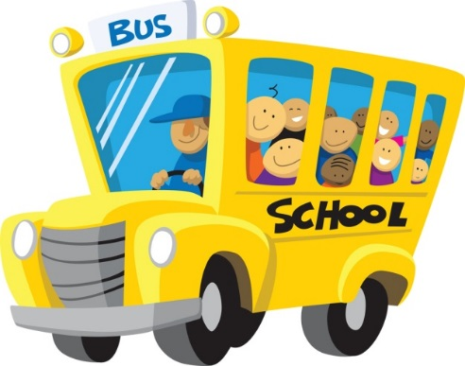
2:35 Clean up and Return to Classes
2:40 Pack Up
2:45 Dismissal from Classroom
* Tuesdays are our exception - 10:45 - 11:30 and 12:30 - 1:15 Students are split into 2 groups and attend computer and Library.

